1. 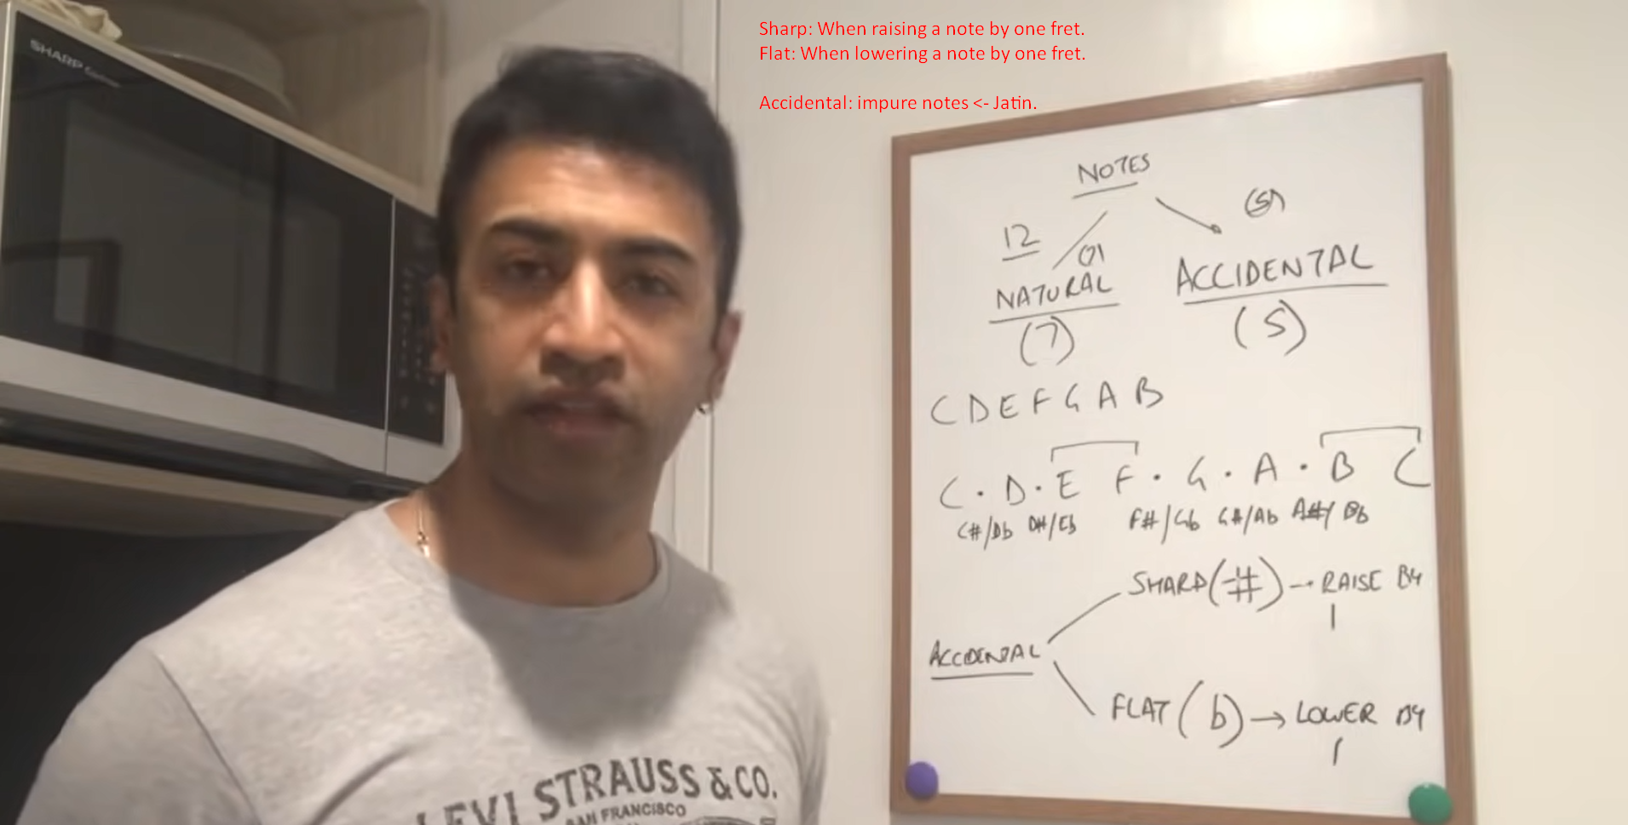
2. Enharmonic Equivalent: A note having two different names such as C#/Dflat.
3. Normally musicians talk in term of sharp but jazz musicians use flats too but at some places flat terms make communication easy.
4. So far we talked about term Notes. Now let’s talk about intervals.
5. **Intervals**
6. Basic building blocks of music.
7. Communication with other musicians (Guitar, Piano).
8. Half Step = Next Fret/Note = Semi Tone
9. Whole Step = Next to next Fret/Note = Tone
10. **NOTE**: To understand music theory, you must have to memorize major scales.